19
numberToGuess = int(input('Player One enter your chosen number: '))
while numberToGuess < 1 or numberToGuess > 10:
print('Not a valid choice, please enter another number: ')
numberToGuess = int(input())
guess = 0
numberOfGuesses = 0
while guess != numberToGuess and numberOfGuesses < 5:
guess = int(input('Player Two have a guess: '))
numberOfGuesses += 1
if guess == numberToGuess:
print('Player Two wins')
else:
print('Player One wins')

20
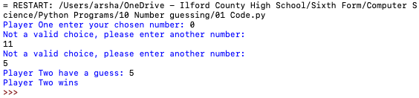

21